. “EXPENSE TRACKER”

A Project Report submitted
In partial fulfillment of the requirements for the award of the degree of
BACHELOR OF TECHNOLOGY IN
COMPUTER SCIENCE & ENGINEERING (DATA SCIENCE)

Submitted by
KARAKAVALASA VENKATA
ANJELITA
Regd No. 2025398263

Under the esteemed guidance of

Dr. Devarapalli Ravi Kishore, Associate Professor, CSE DS



DEPARTMENT OF COMPUTER SCIENCE AND ENGINEERING (DATA SCIENCE)

GITAM SCHOOL OF TECHNOLOGY
GITAM (Deemed to be University)
VISAKHAPATNAM
2025

DEPAR.
TMENT OF COMPUTER SCIENCE AND ENGINEERING (DATA SCIENCE)

GITAM SCHOOL OF TECHNOLOGY
GITAM (Deemed to be University)



DECLARATION

I hereby declare that the project report entitled “EXPENSE TRACKER” is an original work done in the Department of Computer Science and Engineering (Data Science), GITAM School of Technology, GITAM (Deemed to be University) submitted in partial fulfillment of the requirements for the award of the degree of B.Tech. in Computer Science and Engineering. The work has not been submitted to any other college or University for the award of any degree or diploma.

Date:

Registration No Name Student Signature
2025398263
K.V.ANJELITA

DEPAR.
TMENT OF COMPUTER SCIENCE AND ENGINEERING (DATA SCIENCE)
GITAM SCHOOL OF TECHNOLOGY
GITAM (Deemed to be University)



CERTIFICATE

This is to certify that the project report entitled “EXPENSE TRACKER” is a bonafide record of work carried out by KARAKAVALASA VENKATA ANJELITA, Regd No 2025398263, submitted in partial fulfillment of requirement for the award of degree of Bachelors of Technology in Computer Science and Engineering (Data Science).

Date :

Project Guide
Dr. Devarapalli Ravi Kishore Associate Professor

. TABLE OF CONTENTS

S.No | Description | Page No.
1. | Introduction 5
2. | Aim of the Project 5
3. | Problem Definition & Objectives 6
4. | Code For The EXPENSE TRACKER 9
5. | Outputs 14
6. | Future Work 18
7. | Conclusion 19

INTRODUCTION

Managing personal finances is an important skill in everyday life. Many people find it difficult to keep track of where their money is spent, which can lead to unnecessary expenses and poor financial planning. An Expense Tracker is a useful tool that helps individuals record, monitor, and analyze their daily spending.

The main purpose of an expense tracker is to provide a simple and organized way to track income and expenses. By recording transactions regularly, users can understand their spending habits, identify areas where they may be overspending, and make better financial decisions.

This project focuses on developing an expense tracker that allows users to enter their expenses, categorize them, and view their financial records easily. The system helps users maintain transparency in their spending and promotes better budgeting practices. Overall, the expense tracker acts as a helpful tool for improving financial awareness and managing money more effectively.

Additionally, an expense tracker helps users maintain a clear record of their financial activities. It allows individuals to review their past transactions and understand their spending behavior more effectively. By analyzing this information, users can make better financial decisions and improve their money management skills. The system also encourages people to develop a habit of recording expenses regularly, which leads to greater financial awareness.

Furthermore, an expense tracker can help users compare their income and expenses over a period of time. This comparison helps in identifying savings opportunities and controlling unnecessary spending. The use of such a system makes financial management more organized, efficient, and convenient. In today's digital world, using simple technological tools like an expense tracker can greatly assist individuals in maintaining financial stability and achieving their financial goals.

AIM OF THE PROJECT

Expense Tracker
The main aim of this project is to develop a simple and efficient system for tracking daily expenses. The project is designed to help users manage their personal finances in an organized and systematic way. It allows individuals to record their income and expenses so that they can clearly understand how their money is being spent.

Another aim of this project is to create awareness about financial management and budgeting. By maintaining a record of expenses, users can identify unnecessary spending and make better financial decisions.

The expense tracker helps users develop the habit of monitoring their daily expenditures regularly.
This project also aims to provide a user-friendly platform where users can easily add, view, and manage their expenses.

The system is designed to simplify the process of recording financial transactions and maintaining financial records. It helps users categorize their expenses into different groups such as food, transportation, shopping, entertainment, and utilities.

The expense tracker also aims to improve financial discipline by encouraging users to stay within their budget. By reviewing their expense records, users can understand their spending patterns and adjust their financial habits accordingly.

This helps in planning future expenses and achieving financial goals.
Another objective of this project is to demonstrate the practical application of programming concepts in solving real-life problems. Through this project, users can see how technology can be used to make financial management easier and more efficient.

The project also aims to reduce the difficulty of manually tracking expenses using notebooks or papers. Instead, the system provides a digital method to store and manage financial data in a structured manner.

Overall, the aim of the expense tracker project is to promote better financial planning, improve money management skills, and provide a convenient tool for recording and analyzing personal expenses.

PROBLEM DEFINITION AND OBJECTIVES

PROBLEM DEFINITION

In today's fast-paced world, many individuals find it difficult to keep track of their daily expenses. People often spend money on various activities such as food, transportation, entertainment, and shopping without maintaining a proper record. As a result, they may lose track of where their money is being spent, which can lead to overspending and poor financial management.
Traditional methods of recording expenses, such as writing them in notebooks or manually calculating totals, can be time-consuming and inefficient. These methods also increase the chances of errors and make it difficult to analyze spending patterns over time. Without a proper system to track expenses, individuals may struggle to maintain a budget and achieve their financial goals.
Therefore, there is a need for a simple and efficient system that allows users to record, manage, and monitor their expenses in an organized manner. An expense tracker helps solve this problem by providing a digital platform where users can easily record their daily expenses, categorize them, and review their spending habits. This system helps users gain better control over their finances and make informed financial decisions.

OBJECTIVES

MAIN OBJECTIVES:

The main objective of the Expense Tracker project is to develop a system that helps users manage and monitor their daily expenses effectively.

One of the key objectives is to provide a simple and user-friendly platform where users can easily record their financial transactions. The system aims to help individuals maintain a proper record of their income and expenses.

Another objective is to help users understand their spending patterns. By categorizing expenses such as food, travel, shopping, and entertainment, the system makes it easier to analyze where money is being spent.

The project also aims to encourage users to develop better financial habits by regularly tracking their expenses. This helps users become more aware of their spending behavior and manage their finances more responsibly.

Another important objective is to reduce the difficulties associated with manual expense tracking. By using a digital system, users can store and access their financial data more efficiently.

The expense tracker also aims to support better budgeting by allowing users to compare their income and expenses. This helps individuals identify areas where they can reduce spending and increase savings.

Finally, the objective of this project is to demonstrate how technology and programming can be used to create practical solutions for everyday financial management problems.

CODE

# ==============================
# EXPENSE TRACKER
# ==============================
import csv
expenses = []

def add_expense():
name = input("Enter expense name: ")
amount = float(input("Enter amount: "))
expenses.append({"name": name, "amount": amount})
print("Expense added")

def show_expenses():
if not expenses:
print("No expenses found")
else:
print("\nExpenses:")
for i, exp in enumerate(expenses):
print(f"{i+1}. {exp['name']} - ₹{exp['amount']}")

def total_expense():
total = sum(exp["amount"] for exp in expenses)
print("Total Expense:", total)

def save_expenses():
with open("expenses.csv", "w", newline="") as file:
writer = csv.writer(file)
writer.writerow(["Name", "Amount"])
for exp in expenses:
writer.writerow([exp["name"], exp["amount"]])

def load_expenses():
try:
with open("expenses.csv", "r") as file:
reader = csv.DictReader(file)
for row in reader:
expenses.append({
"name": row["Name"],
"amount": float(row["Amount"])
})
except:
pass

# Load previous data
load_expenses()

# Menu loop
while True:
print("\n1. Add Expense")
print("2. View Expenses")
print("3. Total Expense")
print("4. Exit")
choice = input("Enter choice: ")
if choice == "1":
add_expense()
elif choice == "2":
show_expenses()
elif choice == "3":
total_expense()
elif choice == "4":
save_expenses()
print("Expenses saved. Exiting...")
break
else:
print("Invalid choice")

OUTPUTS

Initial Output:
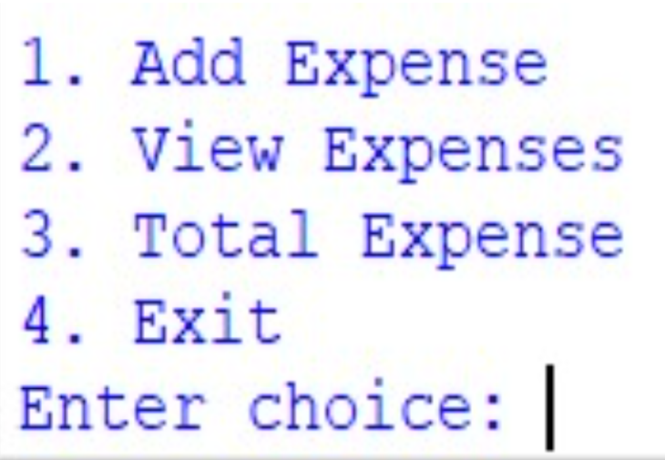

1st Option and Output:

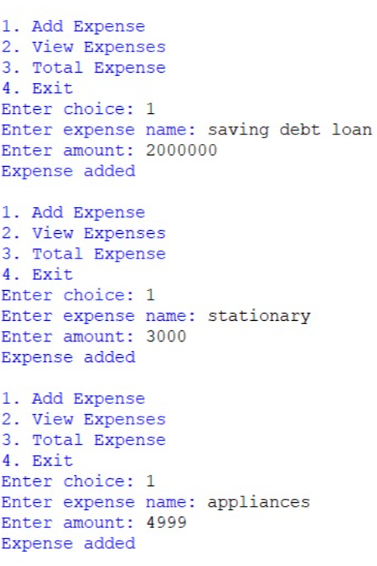

2nd Option and Output:

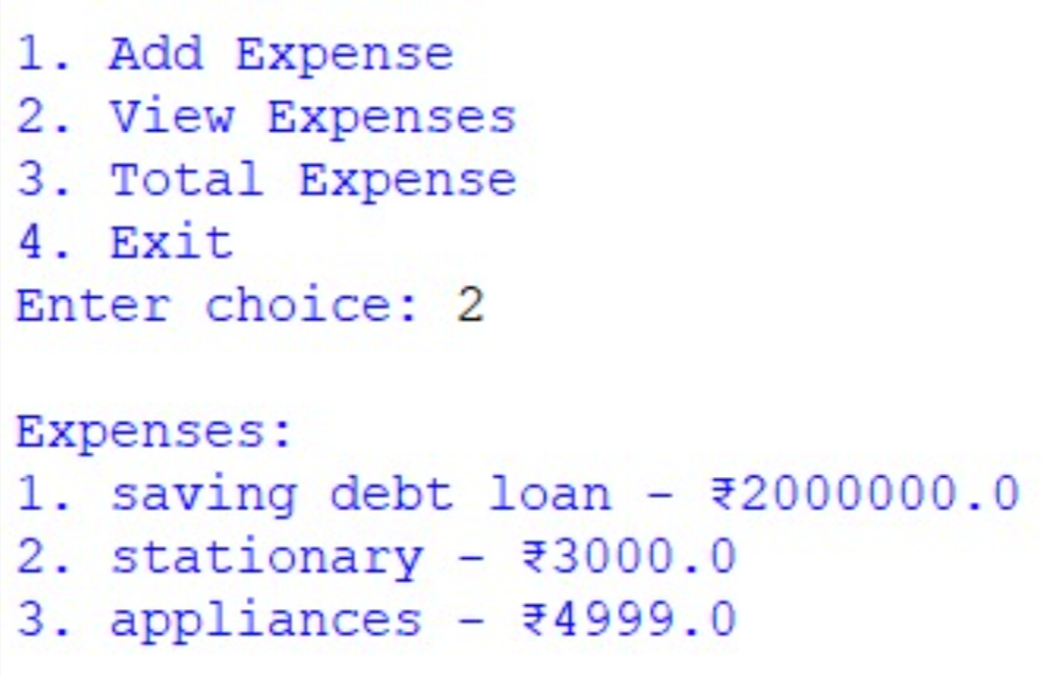

3rd Option and Output:

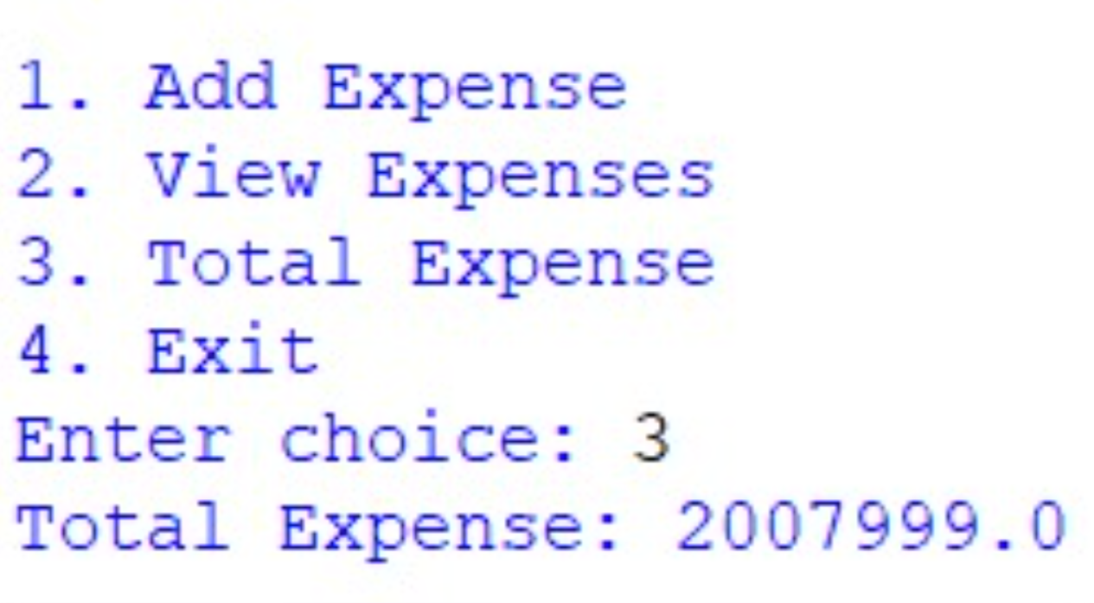

4th Option and Output:

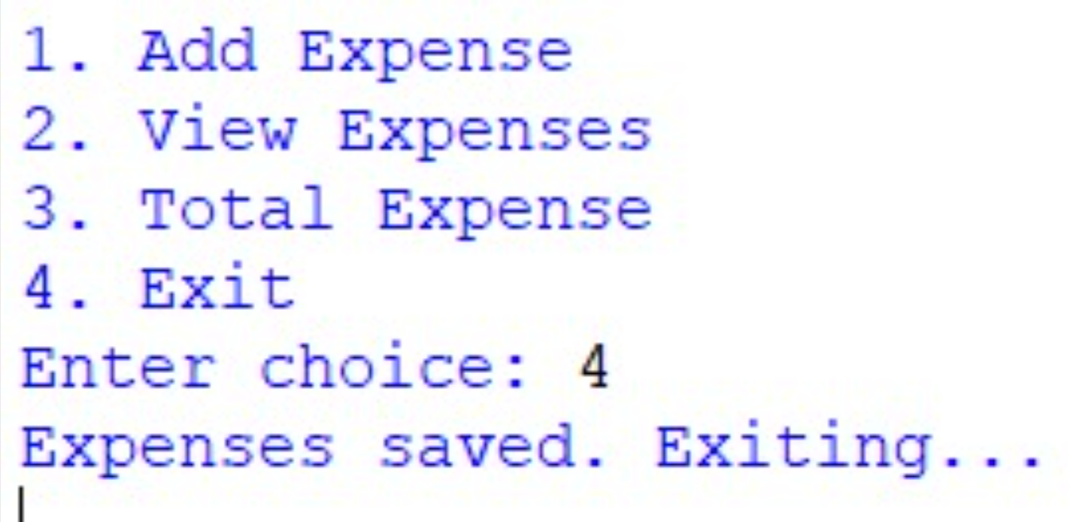

FUTURE WORK

The Expense Tracker system can be further improved by adding several advanced features to make it more useful and efficient for users. In the future, the application can be enhanced to support multiple users so that different individuals can maintain their own expense records within the same system. This will make the system more flexible and suitable for families or groups who want to manage their finances together.
Another improvement that can be made is the addition of graphical representations such as charts and graphs. These visual tools will help users easily understand their spending patterns and financial trends over time. By viewing graphs of monthly expenses or category-wise spending, users can make better financial decisions.
The system can also be enhanced by adding a budgeting feature. This feature would allow users to set spending limits for different categories such as food, transportation, or entertainment. When the expenses exceed the set budget, the system can notify the user and help them control unnecessary spending.
In future versions, the expense tracker can also include a reminder or notification system. This feature can remind users to regularly update their expenses so that they do not forget to record their daily transactions. Notifications can also alert users when they are close to exceeding their monthly budget.
Another possible improvement is the integration of cloud storage. By storing data in the cloud, users will be able to access their expense records from different devices such as mobile phones, tablets, or computers. This will make the system more convenient and accessible.
Security features can also be improved in the future. For example, user authentication through passwords or biometric verification can be added to protect sensitive financial data. This will ensure that only authorized users can access the expense records.
The expense tracker can also be expanded into a mobile application so that users can easily record expenses while they are on the go. A mobile-friendly interface will make the system more practical and user-friendly.
Finally, future developments may include automatic expense tracking through bank integration or digital payment systems. This would allow the system to automatically record transactions, reducing the need for manual input and making the expense tracking process faster and more accurate.

CONCLUSION
The Expense Tracker project provides a simple and effective solution for managing personal finances. It helps users record and monitor their daily income and expenses in an organized manner. By maintaining proper records of financial transactions, individuals can gain a clear understanding of their spending habits and make better financial decisions.
This system reduces the difficulties of manually tracking expenses and provides a more efficient way to manage financial data. It allows users to categorize their expenses, review their spending patterns, and maintain better control over their budget. As a result, users can identify unnecessary expenditures and plan their finances more effectively.
The project also demonstrates how technology can be used to solve real-life problems in a practical way. It highlights the importance of financial awareness and encourages individuals to develop responsible money management habits.
Overall, the Expense Tracker serves as a useful tool for improving financial discipline and promoting better budgeting practices. With further improvements and additional features, the system can become even more powerful and beneficial for users in managing their personal finances.

